South Coast District Women's Bowling Association
Inc.
Please complete & return to District Secretary, Lynne Clarke 48/62 Island Pt Rd St Georges Basin NSW 2540 or email to scdregion8@hotmail.com after your election of officers for 2019/20
Women's Bowling Club
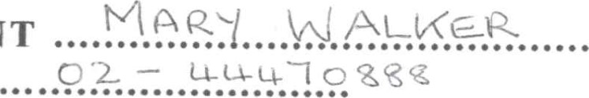
PRESIDENT Telephone
Address
QSuo
Email
Address...
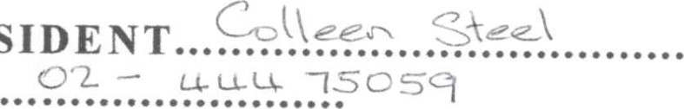
VICE PRESIDENT Telephone
Address
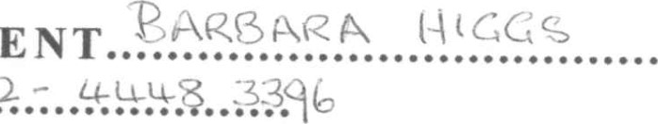
VICE PRESIDENT Telephone....
Address
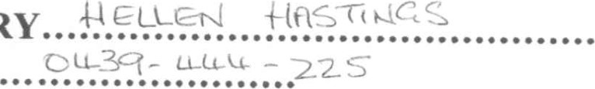
SECRETARY
Telephone
Address
Email address

